Coursera Capstone Assignement
-FULL-

- Business Problem:

The problem treated in this particula project was : where would a good spot for a new coffee shop be in Los Angeles?

Such a problem would require both location data (taken from Foursquare) as well as some form of machine learning algorithm to help in finding the best location as sifting by hand through all the data to find the best location would not be very efficient or even feasible in a city the size of L.A.
Being a large city populated by people from all ages and all walks of life, all going about their day to day activities, coffee would be quite an essential commodity. We can see a large number of coffee shops already making large amounts of money and being quite popular in the area, so a new one in a as of yet untaped or underserved area of the city could produce a great return on investment as well. Such a venue often requires a small initial investment(compared to a restaurant or other large and expensive venues) and as such the demand for a good location could come from anyone, from young entrepreneurs all the way up to large, well established chains, such as Starbucks.
Coffee shops often live or die based on their location, coffee is a simple commodity and for the working people, even a bad coffee is a good coffee as long as it’s hot and close by. Even a large brand can fail if it sets up shop in the middle of nowhere or in an already oversaturated area of the city, so a resource that would help direct the initial investment in a good area and that would help increase the R.O.I. would find quite a large demand on the market.

- Data :

The main data requirements of this particular project are a list of all the various cities of the Los Angeles greater metropolitan area and their location and a list of all ( or most ) of the venues in each location.

The data regarding the venues was extracted from the Foursquare dev API. I shall use data regarding all venues in a city and not just coffee shops, as there can be other factors that could influence the best location. Perhaps an area has no competition and in theory would make a great location, however after checking the data we can see that this particular location is a nature reserve so putting a coffee shop there would not only be quite unreasonable, but also pretty much impossible. Besides, the data Foursquare provides is easy to work with and quite comprehensive.

The data regarding the cities in LA is taken from an archive of the USPS at https://simplemaps.com/data/us-zips. This contains data of the USPS zip codes(along with location data long-lat for each), but it has to be sifted for relevant information. As such a .csv file was uploaded to Github for ease of use and then retrieved from there into the project notebook. The data was then scrubbed as the initial .csv file holds the zips from everywhere inside the US along with some extra columns that are not necessary for this particular project. The data that was kept was data about city name, zip code, longitude and latitude and the population numbers( population data can be used to get a feeling on what kind of profit a certain area might bring ).

- Exploratory Data Analysis:

The point of this particular project was predicting the best place for a new coffee shop. After the data was scrubbed and ready to be used, it had to be somehow interpreted. The main points at play here would be the top 10 venue types in each city in the Los Angeles greater municipal area. A total of 1434 venues were taken from the Foursquare database and used to help with this task.

- First order of business was quantifying the venue type, as this is the most important information.
- Second, the venues had to be split by city/neighbourhood.
- Third, a ranking of the most popular 10 venue types had to be compiled for each city/neighbourhood.
- Fourth, the cities/neighbourhoods had to be grouped based on this information in order to facilitate choosing the best place for our new coffee shop.

Problems appeared during phase c) as there were several locations with not enough data. These outliers were considered irrelevant enough to be discarded.
The cities were grouped in 8 labels by using k-means. This seems to be the best number as it gives us quite a good accuracy without loosing the ability of grouping the cities effectively.

After the groups were formed each of them was analysed for suitability by the following criteria:

- there is no coffee shop in the top 3 most popular venues in the cluster( competition would be too great as there are a number of well established coffee shops )
- there is no restaurant( other than fast food ) in the top 3 most popular venues in the cluster( restaurants offer drinks, a coffee shop would find again far too much competition )
- there is another coffee shop in the top 10 most popular venues( the market for such a venue is there, however it is not saturated or dominated )
- there is some form of restaurant in the top 10 most popular venues( there may be demand for a dedicated coffee shop )
- there is some form of outdoor activities venue ( parks and such, people may like a coffee before or after a pleasant stroll )
- if 5 does not apply, there have to be shops or other businesses in the cluster in the top 5 most popular
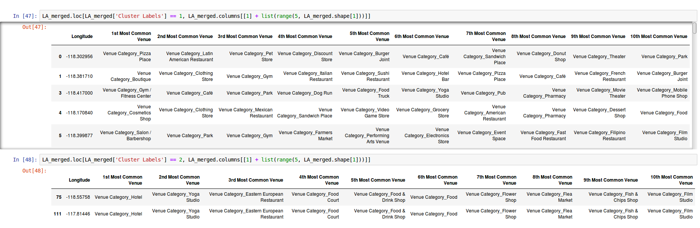
Here we can see 2 clusters. We can see the location of each and what the most popular venues are. Based on this information on could decide if a cluster would be either good or bad for our new coffee shop.
After a group or a number of groups are selected as suitable by the client, we can check the map created in this project for information on both population numbers in the area and nearby groups and what they contain.
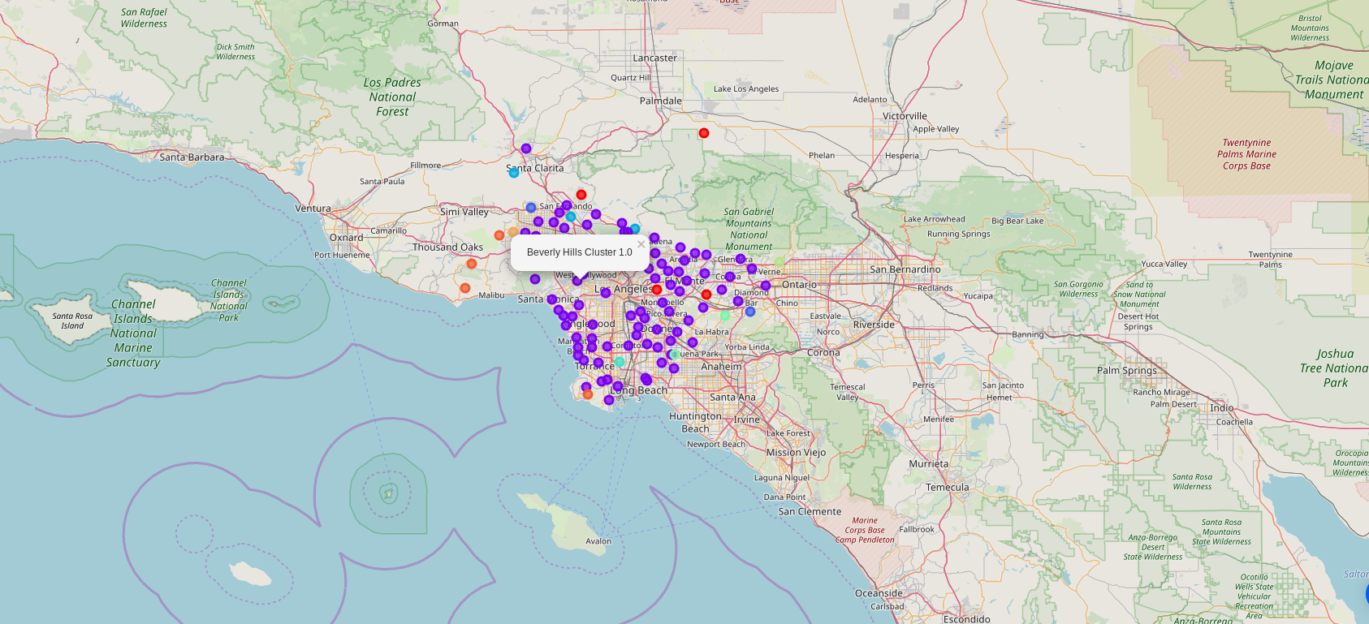
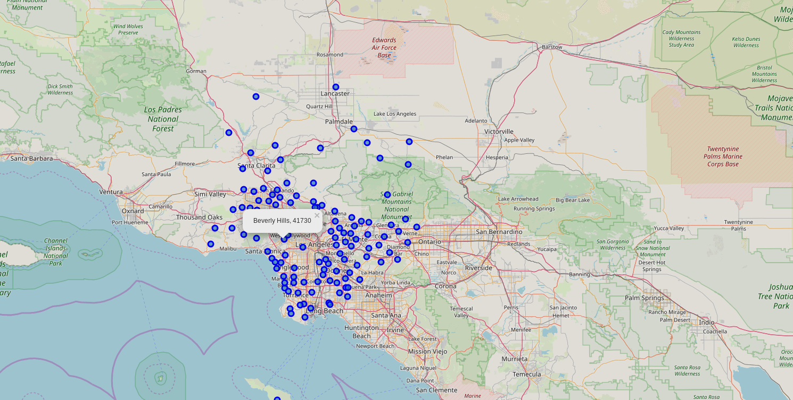
Here we can see the map after clustering. We can see for example that should our client choose to base the new coffee shop in Beverly Hills, all the neighbourimg clusters will be similar( label 1 ).

Here we can see the population map, a resource that can be used in order to get an idea about how much foot traffic the new coffee shop will have( in the case of our example we see we have a population of 41730, quite a lot of people )

- Model:

The model used for this project is fairly simple, however it is also quite precise, the clusters formed after k-means are well differentiated and there id enough information to make a good and informed decision.

- Conclusion:

In this study the business problem is quite well resolved, the data is comprehensive and quite useful. The various location are grouped and easy to interpret and localize on the map. This particular application can be used in conjuncture with a similar projects documenting real estate prices in the same are.

- Future:
As stated above an evolution to this model may be achived by adding a real estate component along with the population and venue type component. With such a project one could easily identify both initial investment as well as profit, not only for a coffee shop, but for any type of venue as long as the criteria above mentioned are tweaked.

